1st, we want to know the APIS for creating Binary Heaps 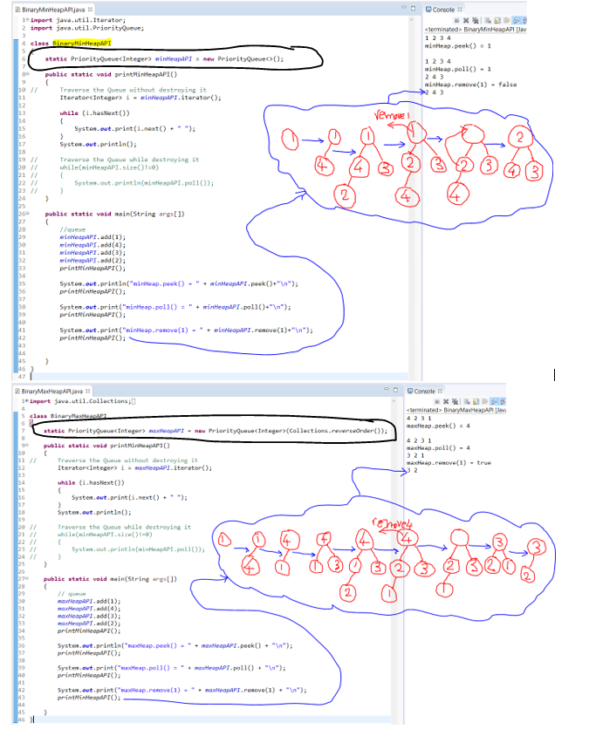

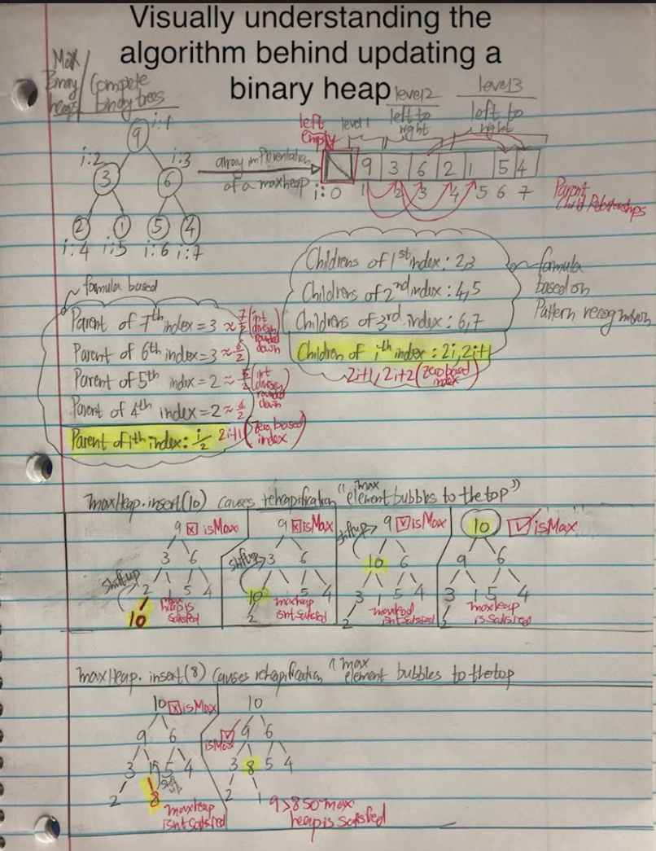

3rd, we want to use the visually understood algorithm to code the Binary Heap data structure from Scratch

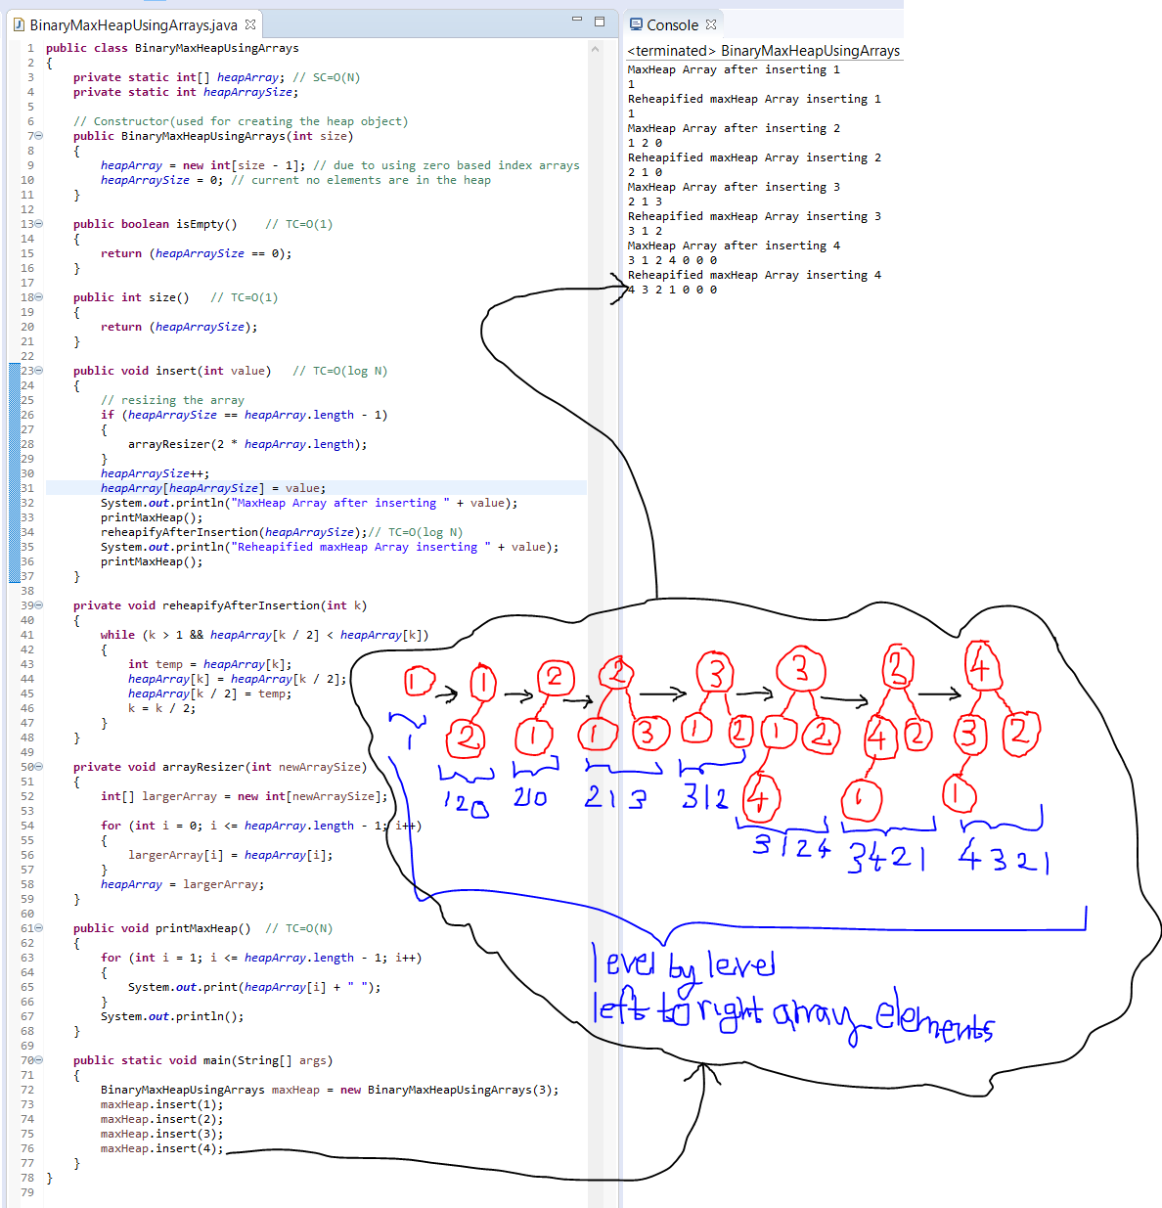

4th refactoring the code to resemble ADT

